Strategic Plan
Updated January 2024

Mission
The College of Education advances education and mental health in Iowa and beyond.

Vision
The best educational and mental health outcomes for all.

Values
Practice integrity. We hold ourselves to the highest standards of honesty, transparency, and ethics. We use our resources efficiently and effectively.

Affirm academic freedom. We freely seek and share knowledge. We are responsible to our disciplines, students, profession, and institution.

Foster belonging. We welcome everyone with respect, care, and dignity. We value diversity, inclusion, and accessibility. We encourage rigorous and respectful dialogue.

Unlock the boundless potential in each person. We build collaborative relationships, meeting people where they are. We challenge and improve systems to empower people to become their best.

Improve continuously. We pursue excellence by learning and improving everything we do.

Implementing the Strategic Plan
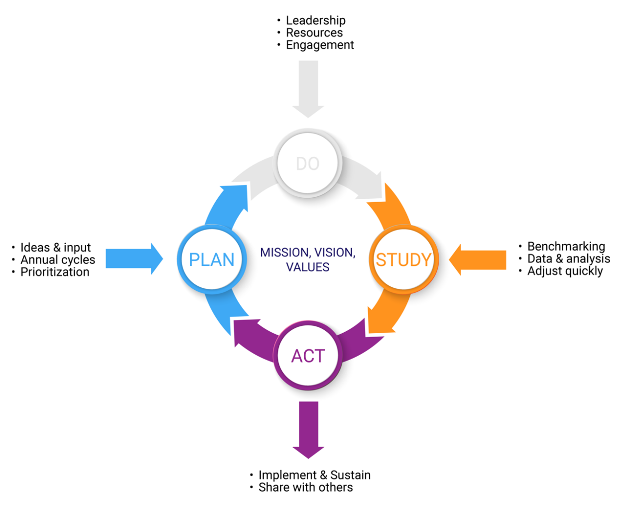

Plan
- Ideas & input
- Annual cycles
- Prioritization

Do
- Leadership
- Resources
- Engagement

Study
- Benchmarking
- Data & Analysis
- Adjust quickly

Act
- Implement & sustain
- Share with others

Strategic Priorities

I. Strategically Grow Enrollment
Measure of success:
- Enrollment disaggregated by program, degree, and funding type.
Action items:
- Recruitment and marketing plans for each program.
- Refine website for clarity of communication and ease of use.
- Build partnerships with UI Admissions, feeder programs, and external collaborators.
- Review and update program offerings to meet student interest and market demands.

II. Promote Student Success and Satisfaction
Measures of success:
- Student satisfaction survey.
- Retention and graduation rates (disaggregated by various demographic groups).
- Licensure success rates.
- Work / educational placement after graduation.
Action items:
- Support high quality instruction.
- Identify and support students at risk of attrition.
- Department and program initiatives for improving student satisfaction.
- Infuse mental health resources and support throughout all we do.

III. Increase our impact on educational and mental health outcomes for our students and for our communities in Iowa and beyond
Measures of success:
- Research productivity.
- Grant proposals and grant awards.
- Research expenditures.
- Number of partnerships with schools, communities, and other organizations in Iowa.
Action items:
- Research support for junior faculty and doctoral students.
- Build long-term collaborative relationships.
- Expand use of GRSC to support grant proposals.

IV. Build a culture of belonging for students, employees, and guests
Measures of success:
- Students’ sense of mattering.
- Workforce engagement.
- Climate survey.
Action items:
- Department and program initiatives for workforce engagement.
- Enhance and support college-wide community building initiatives and teams.

